1. List all data from table deposit

SELECT \* FROM Deposit;

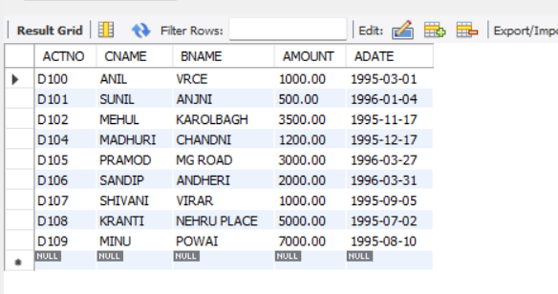

1. List all data from borrow

SELECT \* FROM borrow;

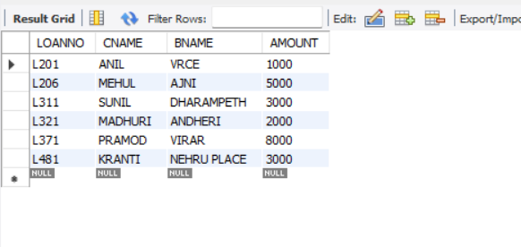

1. List all data from customer

SELECT \* FROM customer;

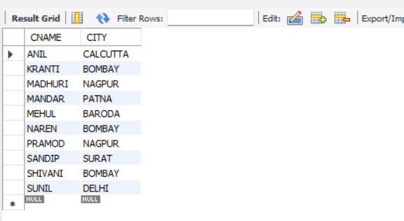

1. List all data from branch

SELECT \* FROM branch;

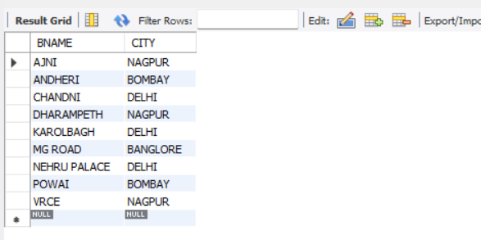

1. Give account no and amount of deposit

SELECT actno, amount FROM deposit;

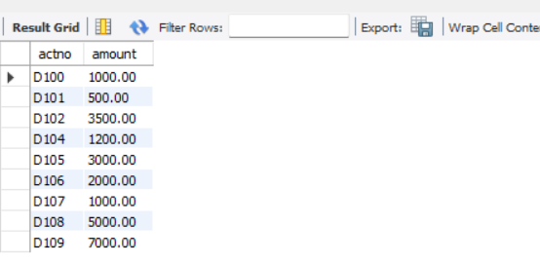

1. Give customer name and account no of depositors

SELECT CNAME, ACTNO FROM DEPOSIT;

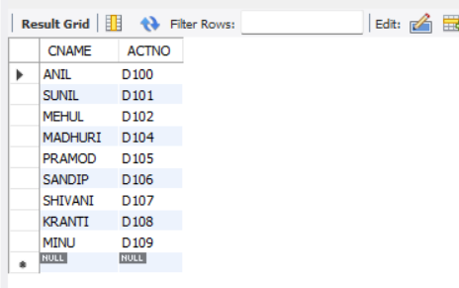

1. Give name of customers

SELECT CNAME FROM CUSTOMER;

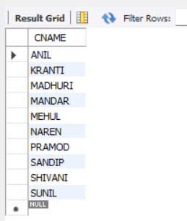

1. Give name of branches

SELECT BNAME FROM BRANCH;

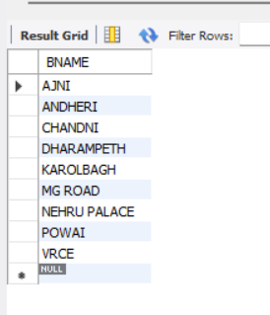

1. Give name of borrows

SELECT CNAME FROM BORROW;

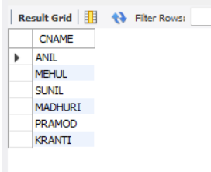

1. Give names of customer living in city Nagpur

SELECT CNAME FROM CUSTOMER WHERE CITY = 'NAGPUR';

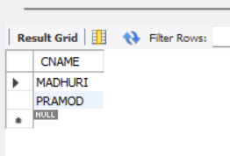

1. Give names of depositors having amount greater than 4000

SELECT CNAME FROM DEPOSIT WHERE AMOUNT > 4000;

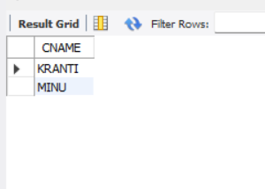

1. Give account date of Anil

SELECT ADATE FROM DEPOSIT WHERE CNAME = 'Anil';

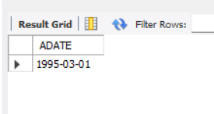

1. Give name of all branches located in Bombay

SELECT BNAME FROM BRANCH WHERE CITY = 'BOMBAY';

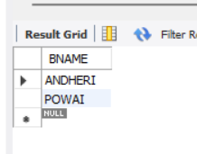

1. Give name of borrower having loan number l205

SELECT CNAME FROM BORROW WHERE LOANNO = 'l205';

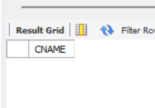

1. Give names of depositors having account at VRCE

SELECT CNAME FROM DEPOSIT WHERE BNAME = 'VRCE';

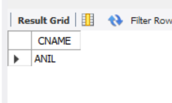

1. Give names of all branched located in city Delhi

SELECT BNAME FROM BRANCH WHERE CITY = 'DELHI';

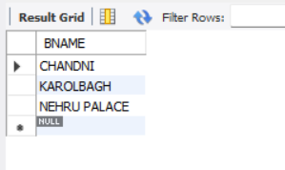

1. Give name of the customers who opened account date ‘1-12-96’

SELECT CNAME FROM DEPOSIT WHERE ADATE = '1996-12-01';

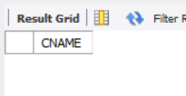

1. Give account no and deposit amount of customers having account opened between dates ‘1- 12-96’ and ‘1-5-96’

SELECT ACTNO, AMOUNT FROM DEPOSIT WHERE ADATE BETWEEN '01-DEC-96' AND '01-MAY-96';

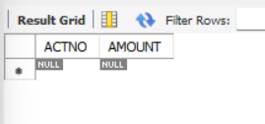

1. Give name of the city where branch KAROL BAGH is located

SELECT CITY FROM BRANCH WHERE BNAME = 'KAROLBAGH';

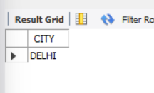

1. Give details of customer ANIL

SELECT \* FROM DEPOSIT WHERE CNAME = 'Anil';

